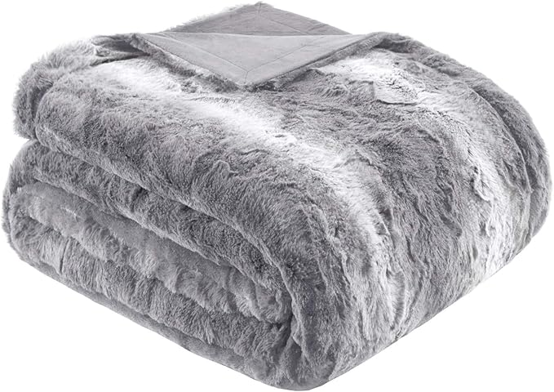

$19

Madison Park Zuri Soft Plush Luxury Oversized Faux Fur Throw Animal Stripes Design, Faux Mink On The Reverse, Modern All Seasons Blanket for Bed, Sofa Couch, Office, Grey, 60x70"